Sl No |  | Name | Designation |  | Age & Date of Birth | Registration No. | Qualification | Date of Joining | Previous Teaching Experience | Address | Email ID | Phone No. | Photo
DEPARTMENT OF MOULIKASIDHANTA
1 |  | Dr.Ratheesh V V | Asso. Prof. |  | 38 Years  07.03.83 | 9066  TCMC | BAMS MD Sidhanta | 01.11.17 | 4 Years | Vengathottathil, ChennaraMalappuram | drrathish83@gmail.com | 9496875716 | 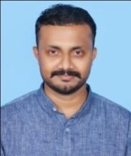
2 |  | Dr. Edwin Kuriakose | Asst. Prof. |  | 32 Years  12.02.89 | TCMC  12831 | BAMS MD Ayurveda Samhitha&Sidhanta | 11.12.17 | 1 year | Aerath House, Nalloornadu PO, ThonichalMananthavady | edwinkuriakose@gmail.com | 8301085180 | 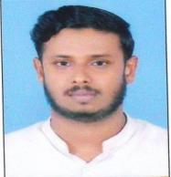
3 |  | Dr. Rismiya S | Asst. Prof. |  | 35 Years  21.07.86 | TCMC  12442 | BAMS MD Ayurveda Samhitha&Sidhanta | 31.03.21 | Nil | Menethu Puthanpurayil, Varavila PO  Clappana  690528 | drrismiyas@gmail.com | 9447867255 | 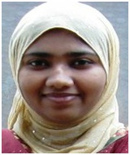
4 |  | Mrs.Prajisha | Sanskrit Lect. |  | 37 Years  22.05.84 |  | MA Sanskrit, BEd. | 01.04.17 | 8 Years | Thalakkottu House, Pannikkotoor, Kerala | prajisuraj@gmail.com | 9645149669 | 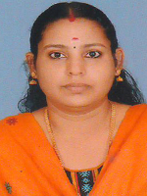
DEPARTMENT OF RACHANASAREERA
5 | Dr.Vipin P C |  |  | Prof. | 40 Years  01.11.81 | TCMC  9431 | BAMS MD Rachanasareera | 01.06.11 | Nil | Uthram  Kollam PO  Koyilandy  Calicut | illuminitipc@gmail.com | 9946954503 | 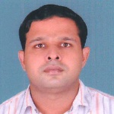
6 | Dr.ArchanaRadhakrishnan |  |  | Asso Prof | 39Years  30.08.82 | TCMC  9933 | BAMS MD Rachanasareera | 01.01.15 | Nil | Neeliparambath House, Chemencheri PO, Kozhikode | drarchanasijesh82@gmail.com | 9567626095 | 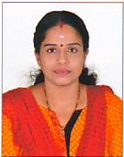
7 | Dr.Dayana H |  |  | Asst. Prof. | 39 Yrs.  01.06.1982 | TCMC  8481 | BAMS MD Rachanasareera | 20.09.21 | Nil | Reena manzil house,Mulakuzha,Chenganur,Alapuzha | drdayanah@gmail.com | 7306883274 | 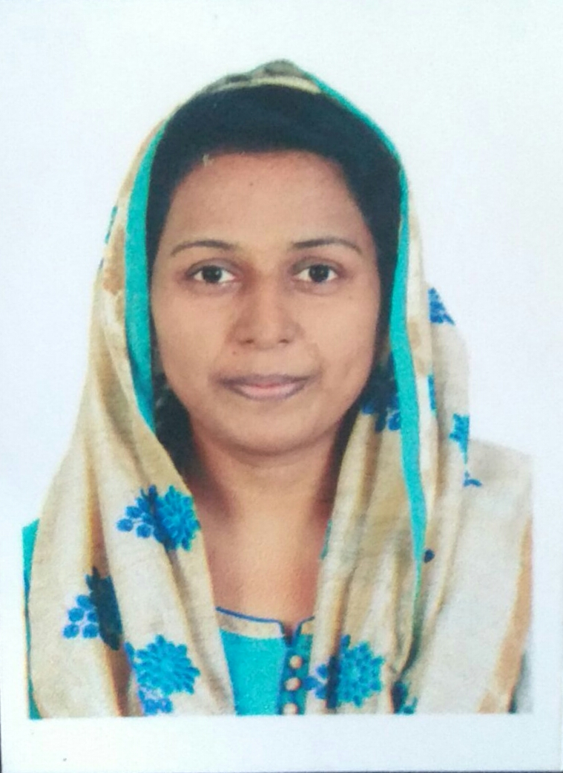
DEPARTMENT OF KRIYASAREERA
8 |  | Dr. Sudhagopalan V S |  | Prof. | 62 Yrs.  16.04.59 | TCMC  5937 | BAMS MD Kriyasareera | 01.07.21 | 23 Yrs | Vaikkattil House  Engandiyur PO  680615 | drsgpal@gmail.com | 9495037812 | 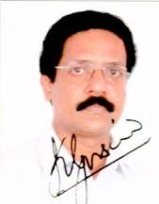
9 |  | Dr.Jaseena C K |  | Asso. Prof. | 35 Years  04.11.85 | TCMC  11303 | BAMS MD Kriyasareera | 21.12.15 | 1 0 Months | JAS Villa, Kolakkattuchalil, Malappuram | drjcnac85@gmail.com | 8086882110 | 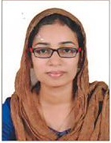
10 |  | Dr. Basil P Jacob |  | Asst. Prof. | 31 Yrs  09.02.90 | TCMC  19529 | BAMS MD Kriyasareera | 04.06.21 | Nil | Peediakkal House, Koodathai PO, Thamarassery Via | drbasilpjacob@gmail.com | 8921319275 | 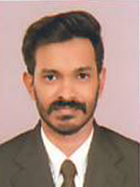
DEPARTMENT OF DRAVYAGUNA
11 |  | Dr. P M Dinesh Kumar |  | Prof. | 49 Years  05.03.72 | TCMC  7633 | BAMS MD Dravyaguna | 27-07-09 | Nil | Pallikkamannil House, Avala PO, Meppayur, Kozhikode | pmdkayurveda@gmail.com | 9497074345 | 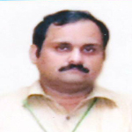
12 |  | Dr. Deepa K K |  | Asso. Prof. | 38  30.05.83 | TCMC | BAMS MD Dravyaguna | 14.06.21 | 9 Yrs | Shivakripa  Mukkam  673602 | drdeepanil@gmail.com | 9978826084 | 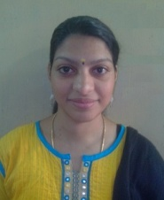
13 |  | Dr. Sreelakshmi S |  | Asst. Prof. | 30 Years  30.11.91 | TCMC  15516 | BAMS MD Dravyaguna | 04.0519 | Nil | Sirakripa  Arinalloor South PO, Kollam | sl301191@gmail.com | 9446673212 | 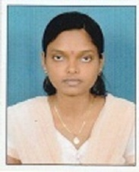
DEPARTMENT OF RASASASTRA
14 |  | Dr. T N Harikrishnan |  | Prof. | 43 Years  09.04.77 | TCMC,  7421 | BAMS MD Rasasastra | 01-05-08 | Nil | UshaNivas, Kalpetta, Wayanad | haritn2000@gmail.com | 9946165249 | 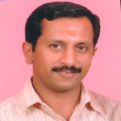
15 |  | Dr.Sugeena P |  | Asst. Prof. | 35 Years  10.04.86 | TCMC  11397 | BAMS MD Bhaishajyakalpana | 01.03.17 | Nil | Ambady House, Kunnembatta, Wayanad | sugeenapalakkara@gmail.com | 9496470224 | 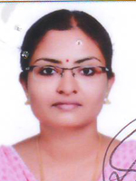
16 |  | Dr. Anwar Niyaz O |  | Asst. Prof | 41 Years  23.05.80 | TCMC  9435 | BAMS MD Rasasastra | 01.05.19 | Nil | Onnarakkattayil House, Punayoor PO, Thrissur | anwarniyaz@gmail.com | 9846648844 | 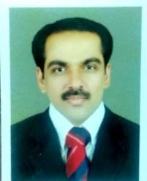
DEPARTMENT OF ROGANIDANA
17 |  | Dr.Sarat K Babu |  | Prof. | 43 Years  02.03.78 | TCMC  7933 | BAMS MD Kayachikitsa | 07.02.19 | 12 Years | Kalissery House, Cakhel Road, Karukadom, Ernakulam | saratayur@gmail.com | 9446413215 | 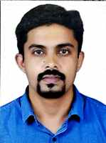
18 |  | Dr. Nidhin.V |  |  | 36Years  4//9/1985 | TCMC: 11823 | BAMS MD in Roganidanan | 20.09.2021 | Nil | Valsalyam, 33/6382 B,Karunabhavan road,Kozhikode- | drnidhinvalsan1985@gmail.com | 9847461114 | 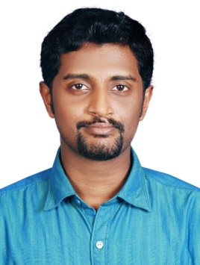
19 |  | Dr. Betsy Baby |  | Asst. Prof. | 36 Years  23.05.85 | TCMC  9556 | BAMS MD in Roganidana | 02.12.19 | Nil | Thanikkal House, Olarikkara, Thrissur | ayudoctor85@gmail.com | 9142319430 | 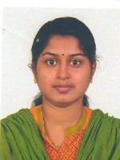
DEPARTMENT OF SWASTHAVRITHA
20 |  | Dr. Suresh V S |  | Asso. Prof. | 40 Years  06.05.81 | TCMC  10230 | BAMS MD Kayachikitsa | 08.03.18 | 5 Years | Koroth House, Nanminda PO,  Balussery  Kozhikode | dr.suresh.v.s@gmail.com | 9605987698 | 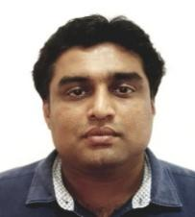
21 |  | Dr.Sijna V P |  | Asst. Prof. | 35 Years  02.05.86 | TCMC  11586 | BAMS MD in Swasthavritha | 25.11.19 | Nil | Flat No. 92, Hilite Eminence, PushpaJuction, Kallai Road, Kozhikode | sijnaraj@gmail.com | 9496136149 | 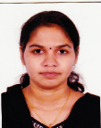
DEPATRMENT OF AGADATHANTRA
22 |  | Dr. Subhasree G H |  | Professor/ Principal. | 41 Years  31.05.80 | 8003  TCMC | BAMS MD Dravyaguna | 01.03.2012 | 3 Years | Akkipoyil House  Nanminda PO  Calicut | sree.gh@gmail.com | 7034122951 | 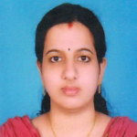
23 |  | Dr.Vivek K |  | Asst. Prof | 32 Years  12.08.89 | 13835  TCMC | BAMS MD Agadathantra | 01.04.17 | Nil | Kedaram, Chemenchery PO, Kozhikode | vivek.vivi89@gmail.com | 9482579006 | 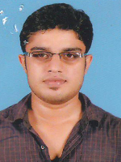
24 |  | Dr.Anjana Mohan |  | Asst. Prof | 33Years  31.12.88 | 13018  TCMC | BAMS MD Agadathantra | 06.0519 | Nil | NellipuramVeedu, Palath PO, Kakkodi | dranjanamohan@gmail.com | 9526062416 | 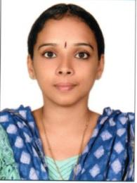
DEPARTMENT OF PRASUTI TANTRA
25 |  | Dr. Sheela D |  | Prof. | 63 Yrs  31.03.58 | 4352  TCMC | BAMS MD RSBK | 14.06.21 | 30 Yrs | SWASTHY  CHIYYARAM  680026 | aleeshdr@gmail.com | 9447126137 | 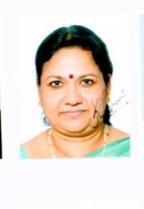
26 |  | Dr. Ranjith R |  | Asso. Prof. | 37 Years | TCMC  9349 | BAMS MS Salyatantra | 01.07.2021 | 10years | BETHESDA,KUDUMBOTTUKONAM, VATTAVILA.P.O,NEYYATINKARA, Kerala | profdrrpranjith@gmail.com | 9846910255 | 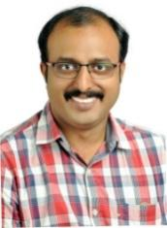
27 |  | Dr.Aswathy Sara Varghese |  | Asst. Prof. | 32 Years  08.07.88 | TCMC  13114 | BAMS MS Prasutitantra | 04.01.18 | Nil | Kolabhagam House, Pathanamthitta | aswathisara88@gmail.com |  | 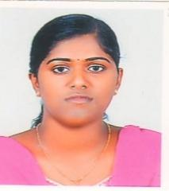
  9961719796
28 |  | Dr. Apila Nath |  | Asst. Prof | 29 years  3.02.92 | TCMC  17446 | BAMS MS Prasutitantra | 31.03.21 | nil | Sreekammangate (H)  Balussery (po)  Kozhikode | mkapilanath@gmail.com | 8217042231 | 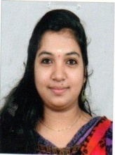
29 |  | Dr. Akhila |  | Asst. Prof | 34 years  05.08.87 | TCMC  12828 | BAMS MS Prasutitantra | 31.03.21 | Nil | Anandam”  Eravannur | drakhila05@gmail.com | 8943700639 | 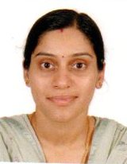
DEPARTMENT OF KOUMARABRITHYA
29 | Dr. Viswanathan K G |  |  | Prof. | 64  26.05.57 | 4351  TCMC | BAMS MD Kayachikitsa | 14.06.21 | 30 Yrs | SWASTHY  CHIYYARAM  680026 | viswanathankgdr@gmail.com | 9495926137 | 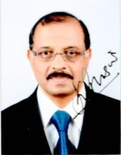
30 | Dr.Subin S |  |  | Asso. Prof. | 34 Years  31.05.86 | TCMC  10231 | BAMS MD Kayachikitsa | 01.06.12 | Nil | Sruthi, Cherukulathoor PO, Medical College, Calicut | subinbams@gmail.com | 9746404053 | 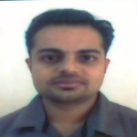
31 | Dr.Anjana R |  |  | Asst. Prof. | 38 Years  24.03.82 | TCMC  9112 | BAMS MD Koumarabrithya | 01.04.17 | Nil | Kalikkodu, Kodasseryparambil, Chevarambalam | anjanachintu@gmail.com | 8075838375 | 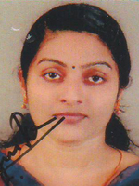
DEPARTMENT OF KAYACHIKITSA
32 |  | Dr.Sarun Mohan |  | Prof. | 37 Years  12.05.83 | TCMC  8968 | BAMS MD Kayachikitsa | 03.03.21 | 10 Years | Kandankerry ,Ithithanam P.O,  Changanachery,Kottayam | drsaranmohan@gmail.com | 9846160449 | 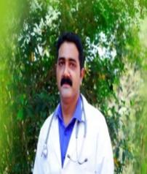
33 |  | Dr.Vineetha N |  | Asso. Prof. | 36 Years  09.12.84 | TCMC  10550 | BAMS MD Kayachikitsa | 16.03.15 | Nil | Bright, Kannancherry, Kallai PO, Calicut | drvineetha sarin@gmail.com | 9747106829 | 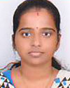
34 |  | Dr.Arathy V |  | Asst. PROF. | 31 Years  12.07.89 | TCMC  12796 | BAMS MD Kayachikitsa | 16.11.16 | Nil | Thiruvonam House, Kizhakkumpatt, Mayanad, Kozhikode | arathiayu@gmail.com | 9895870192 | 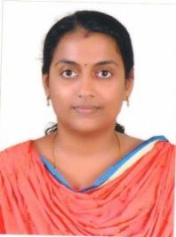
35 |  | Dr.Aparna T |  | Assi Prof | 29 Years  10.05.91 | TCMC  14955 | BAMS MD Kayachikitsa | 03.05.19 | 2 Months | Thokkot House, Cherandathur PO, Thiruvallur,  Kozhikode | dr. aparnathokkot@gmail.com | 9497890675 | 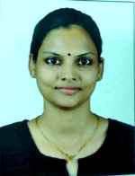
DEPARTMENT OF SALYATANTRA
36 | Dr.Najeeb T K |  |  | Asso. Prof. | 44 Years  10.04.76 | TCMC  7831 | BAMS MS Salyatantra  CRM  CARM | 18.02.21 | 6 Years | Kozhipurath,Kodathoor,Malapuram | drnajeebtk@gmail.com | 9947873825 | 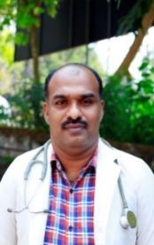
37 | Dr.Aswathy K |  |  | Asst. Prof. | 32 Years  19.11.88 | TCMC 13046 | BAMS MD Salyatantra | 16.11.16 | Nil | Kannadath House, Cheruvannoor, Feroke, Calicut | draswathy88@gmail.com | 9747838548 | 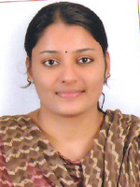
DEPARTMENT OF SALAKYATANTRA
38 | Dr. Alex M George |  |  | Associate Professor | 36 Years  31.05.84 | TCMC  9197 | BAMS MD Salyatantra | 15.01.20 | 8 Years | Muttathara House, Kakkoor PO, Kerala | dralexmgeorge1@gmail.com | 9495382733
39 | Dr.AsifAmeen C P |  |  | Asst. Prof | 31 Years  11.05.89 | TCMC  11144 | BAMS MD Salyatantra | 04.05.19 | Nil | Nusrath House, Thirumithakkode PO, Palakkad | drasifameen@gmail.com | 9645166032 | 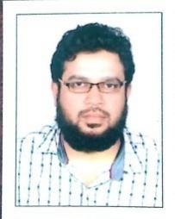
DEPARTMENT OF PANCHAKARMA
40 | Dr. Adarsh E K |  |  | PROF. | 41 Years  14.09.79 | TCMC  8379 | BAMS MD Panchakarma | 01-06-09 | Nil | AdarshNivas, Thekkumthura, Kalpetta, Wayanad | dradarshek@gmail.com | 9961556113 | 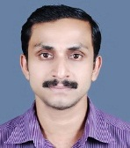
41 | Dr.Mrudula J |  |  | Asst. Prof | 32 Years  22.05.87 | TCMC  11004 | BAMS  MD Kayachikitsa | 01.05.19 | Nil | Kumarabhavan, Chengada, Varanod, Cherthala | mrudu007@gmail.com | 8129529794 | 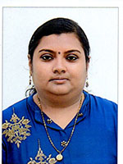
42 | Dr Nayana T M |  |  | Yoga Teacher | 25 Year  17.07.95 | 1108 | BNYS | 10.10.19 | Nil | Kattumadathil House,Kinalur PO, Balussery | nayanamanoj555@gmail.com | 8495884342 | 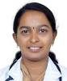
43 | Mr Durgesh Kumar |  |  | Biostatician | 33 Years  01.03.87 | NA | MSc | 01.01.17 | Nil | PakkamHouse,Pakkam PO, Panayal , Kasargod | durgeshkumark@gmail.com | 9048025214 | 